Eclipse-Mars(4.5) Installation and Setup Guide
With PostgreSQL Database Connectivity

Table of Contents

1 Introduction 3
2 Download Eclipse Installer For Windows 3
2.1 Creation of First Java Application in Eclipse 4
3 Creating First Servlet Application Using Eclipse Ide 9
4 Configuring And Using Apache Tomcat With Eclipse 22
4.1 Versioning of Tomcat with Java Environment 27
4.2 The Tomcat configuration in Eclipse 28
5 Download PostgreSQL Installer for Windows.....................................................................................31
6 Sample Database Connectivity With Postgres ....................................................................................48
7 Understanding Java Project Structure 51
8 Directory Structure of Files/Classes In Eclipse 56
9 References 57
10 Document Control 58
10.1 Change History 58
10.2 Open Issues 58

1. INTRODUCTION

Eclipse is an Integrated Developement Environment(IDE) to be used for developing Enterprise and Web Applications in JAVA that requires a Java runtime environment (JRE) in order to run.

Eclipse 4.5 (Mars) was released on June 24, 2015.

Eclipse needs Java Runtime Environment (JRE), or a Java Development Kit (JDK). If you intend to use Eclipse for Java development, then you should install a JDK. If you are not planning to use Eclipse for Java development and want to save some disk space, install a JRE.

2. DOWNLOAD ECLIPSE INSTALLER FOR WINDOWS

You need to download Eclipse IDE from Official website, https://eclipse.org/downloads/

Note: Download Eclipse IDE for JAVA EE Developers (32/64 bit)

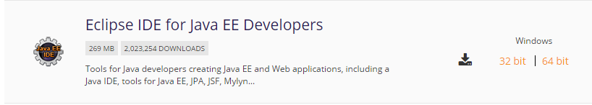

Choose the latest version to download. It will take few minutes to complete the download.(Make sure the compatible type with Windows 32/64 bit, provided with the JDK supported for the same).
Once the download is over, the Eclipse environment will be set in one of the drive mentioned by a programmer/user,and will look like below:
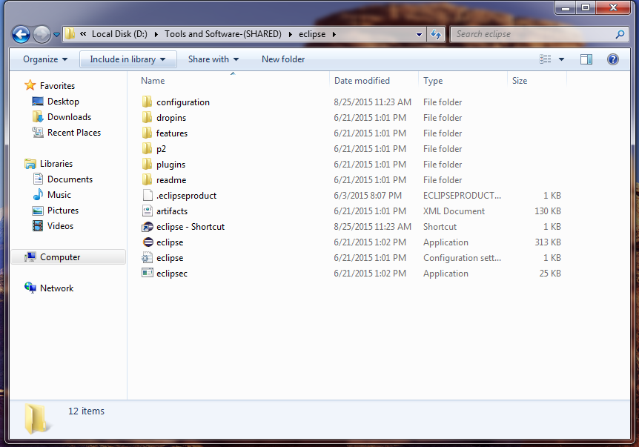

2.1 Creation of First Java Application in Eclipse
Start the Eclipse-Mars with the double-click on the icon given as .
The Workspace Launcher will appear as below:
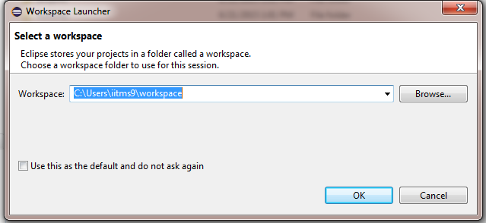

Note:For Eclipse, a workspace is a logical collection of projects. A workspace is a directory on your hard drive where Eclipse stores the projects that you define to it. When you specify this directory name to Eclipse,Eclipse will create some files within this directory to manage the projects.Here we can store all the files and folders as per the convenience.

Once the workspace is defined, the Eclipse will load and boot-up with all the necessary files,as below:

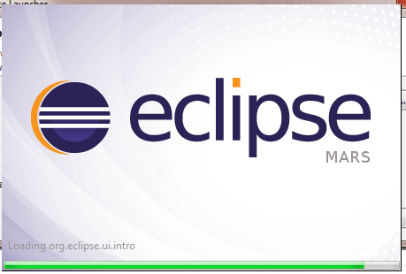

After loading with all the required files and Dir, Eclipse will then appear with Welcome Window, consisting of
Overview of Eclipse,
Some Tutorials,
Try -out Samples,
Latest about the Eclipse in What’s New.

Go to file menu, and now depending upon the programmer’s requirement, New Java Project (Alt+Shift+N) will be opened.

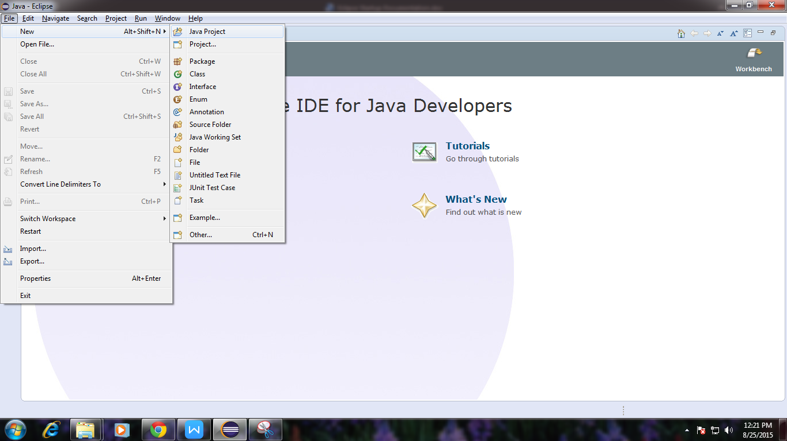

The new project will be defined followed by naming convention as per the Files and Folder Structure in Eclipse.

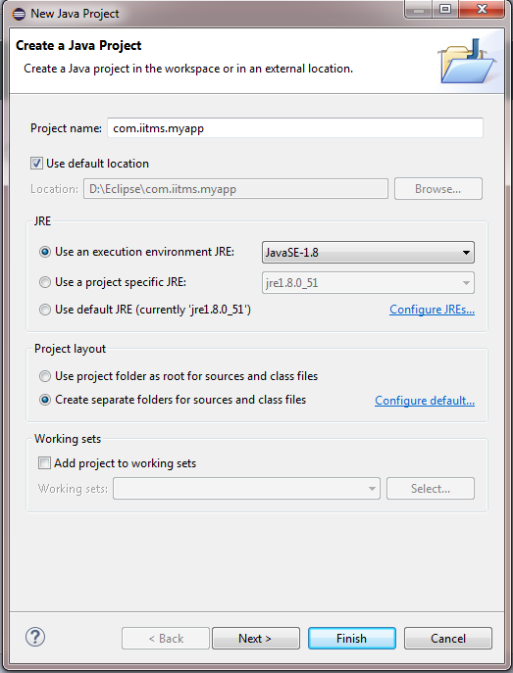

Note: The naming convention of the project and files hierarchy is attached herewith.

By following Diretory structure in Eclipse, New Java Application/Program can be created by right clicking over the Package and then Class.

To run Java Program,
Right click Run as Application or press Ctrl+Shift+X,J
The output console show the result,as below:

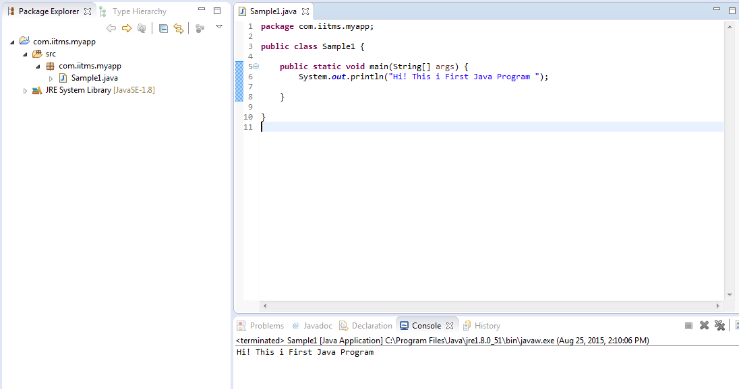

3. CREATION OF FIRST SERVLET APPLICATION USING ECLIPSE IDE

Steps to create Servlet using Eclipse IDE

To create a Servlet application in Eclipse IDE you will need to follow the following steps:

-Goto File -> New -> Dynamic Web Project

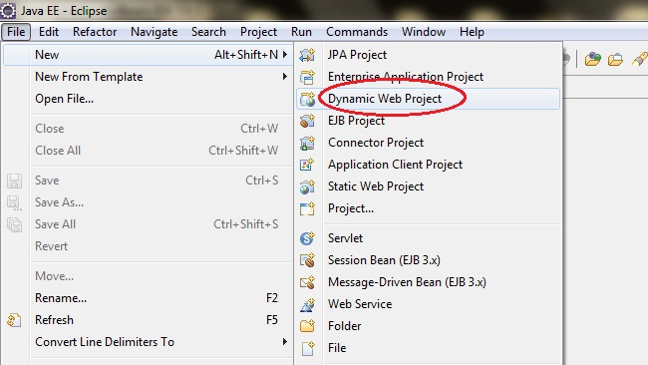

Give a Name to your Project and click Next
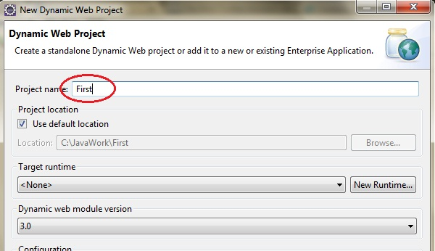

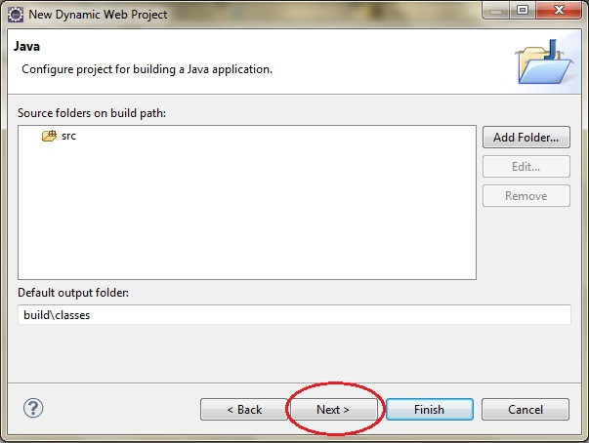

Check Generate web.xml Deployment Descriptor and click Finish

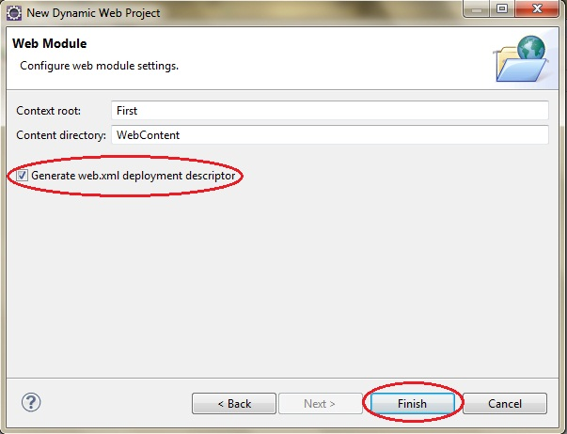

Now, the complete directory structure of your Project will be automatically created by Eclipse IDE.
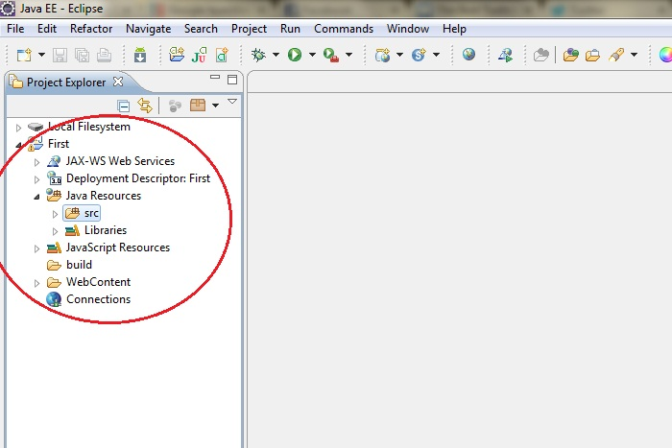

Click on First project, go to Java Resources -> src. Right click on src select New -> Servlet
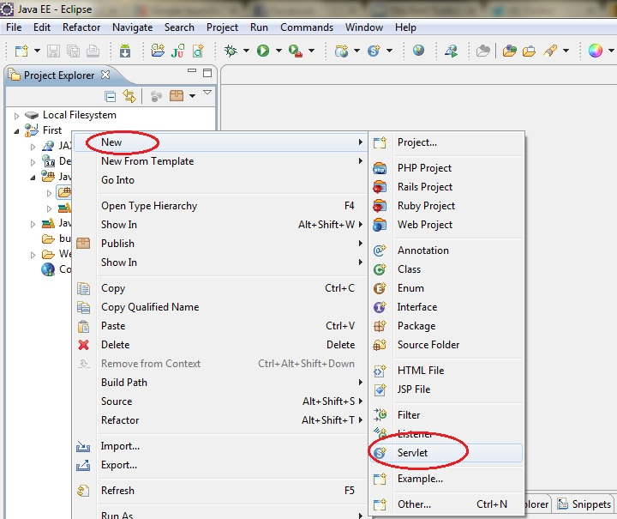

Give Servlet class name and click Next.
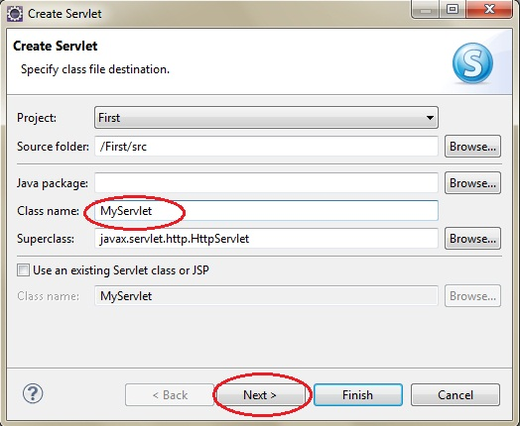

Give your Servlet class a Name.(Followed with the Naming Convention)
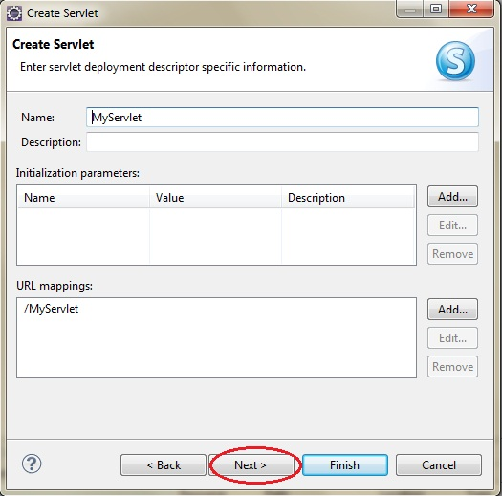

Leave everything else to default and click Finish
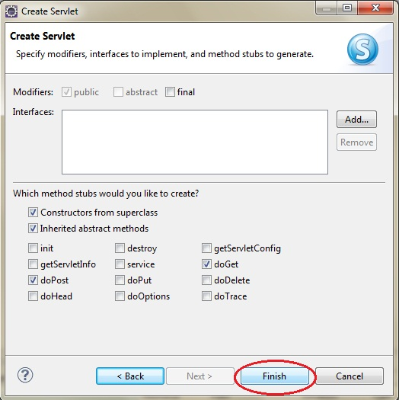

Now your Servlet is created, write some code inside it. You can take reference from the code in the picture below.

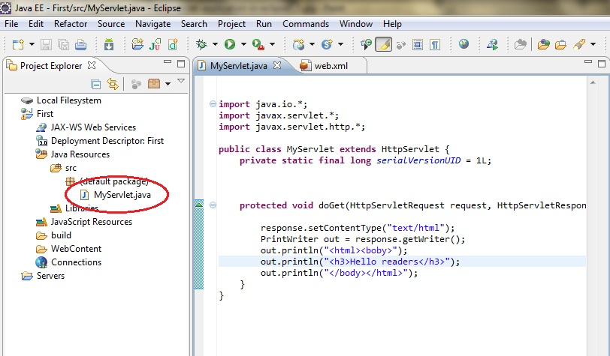

Add servlet-api.jar file to your project.
Click on Libraries, right click on Web App Libraries
select Build Path -> Configure Build Path

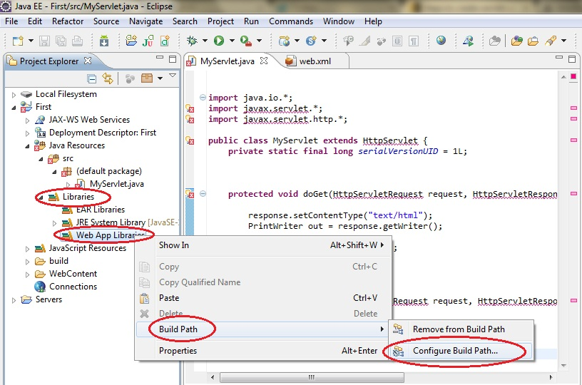

Click on Add External JARs.

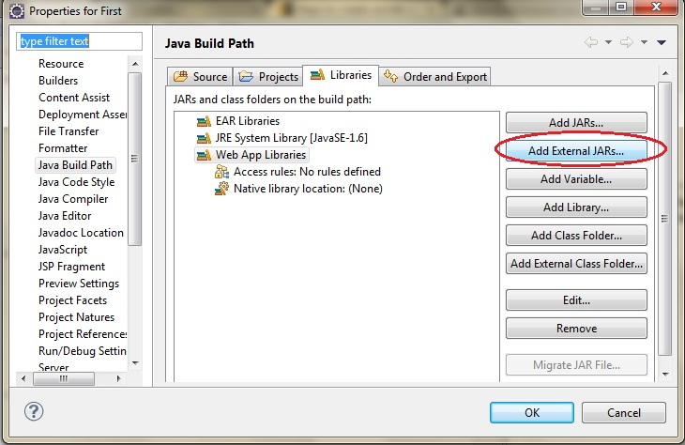

This JAR is now added to your project's build path.

Select servlet-api.jar from Apache Tomcat Directory
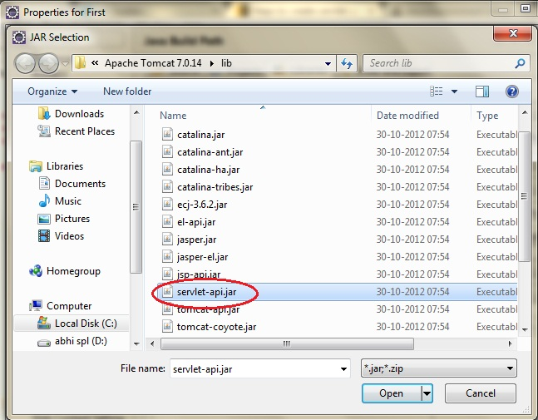

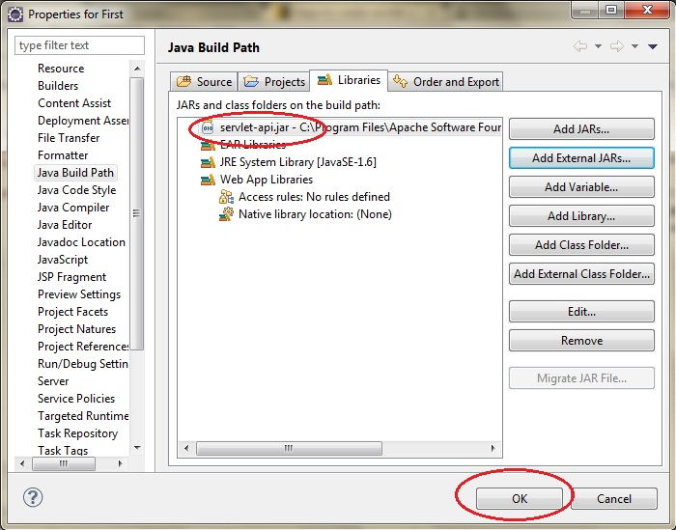

Now Start the server and run the application.
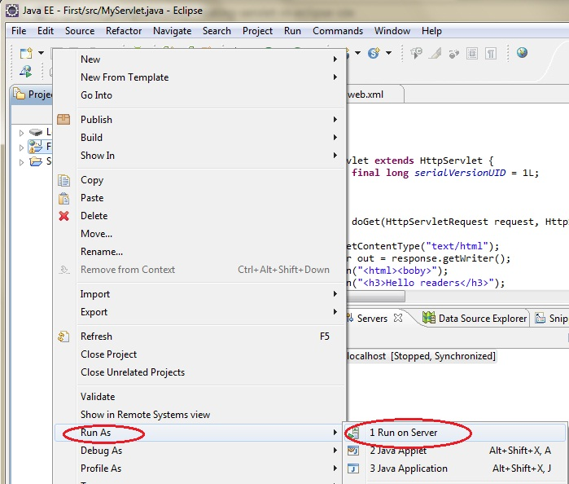

Note:The link is given in an Eclipse-Help to create Web Application.
Web Tools Platform User Guide > Creating Web applications > Creating and editing Web pages - overview > Creating Web Artifacts
Follow the Instruction given in the above link

4. CONFIGURING AND USING APACHE TOMCAT WITH ECLIPSE

To run web application on Tomcat Server, it should be configured previously.

In an Eclipse IDE, the web project can run within dynamic environment. Apache Tomcat will provide this running environment for the same.

The flow will be as follows:

1.Open an Eclipse IDE
2.Create a Dynamic Web Project.
And Follow the instructions given in the window

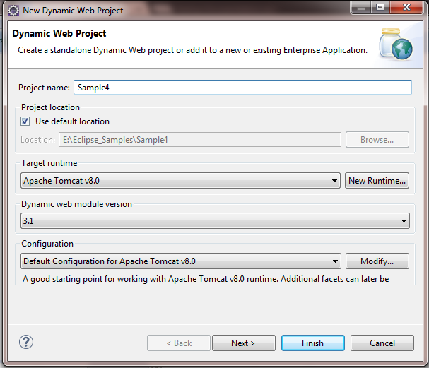

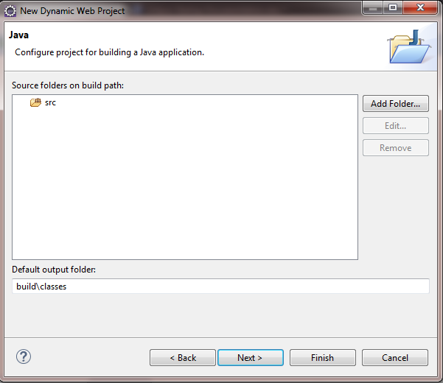

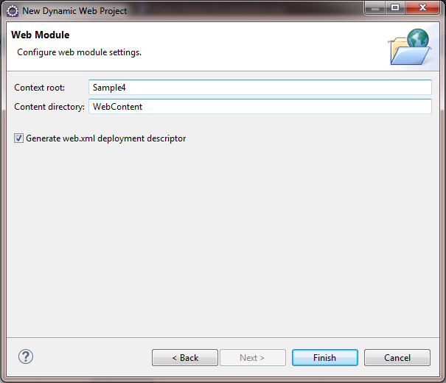

- Create a new jsp file within a project(an extension should be provided)

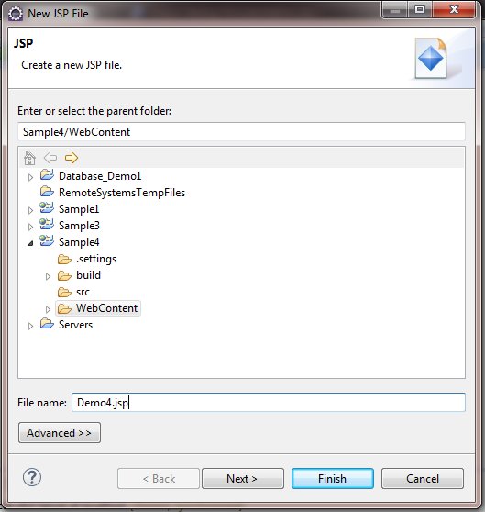

- Once the file is created , its entry should be provided to a deployment descriptor, i.e. Web.Xml, which is available in the WEB-INF folder.

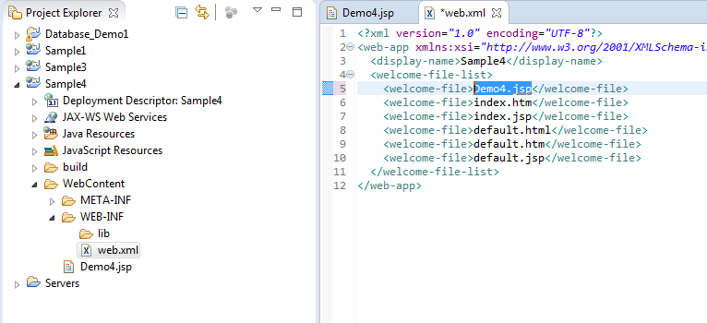

- Save Web.xml and run the project(Run on Server).

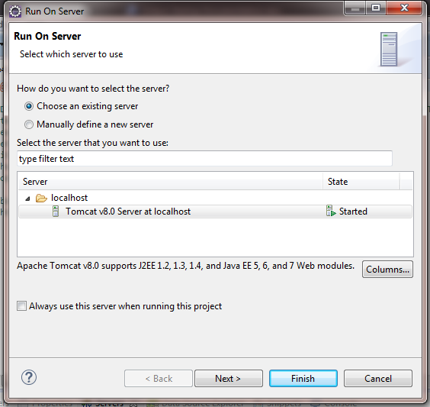

- Restart the server,if required

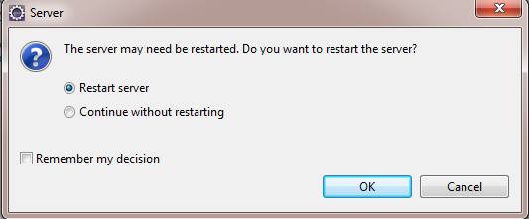

- The Output will be displayed as follows:

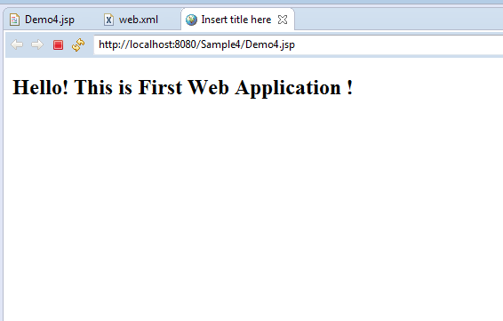

4.1 Versioning of Tomcat with Java Environment

Eclipse can be integrated with the different Versions of Java. The comaptabilitiy of Java Versions with Tomcat Server is given below in the table:

Apache Tomcat version | Actual release revision | Support Java Versions
9.0.x | None | 8 and later
8.0.x | 8.0.26 | 7 and later
7.0.x | 7.0.64 | 6 and later
6.0.x | 6.0.44 | 5 and later
5.5.x (archived) | 5.5.36 (archived) | 1.4 and later
4.1.x (archived) | 4.1.40 (archived) | 1.3 and later
3.3.x (archived) | 3.3.2 (archived) | 1.1 and later

Try downloading the supported tomcat version from the official website:

https://tomcat.apache.org/download/

Once the tomcat is downloaded, Unzip it in the specified folder. In this case,
C:\Program Files\apache-tomcat-7.0.34
4.2 The Tomcat configuration in Eclipse

Start an Eclipse
Go to Windows menu, click over Preferences, on the left side Panel,
Server tab will appear,click over it.

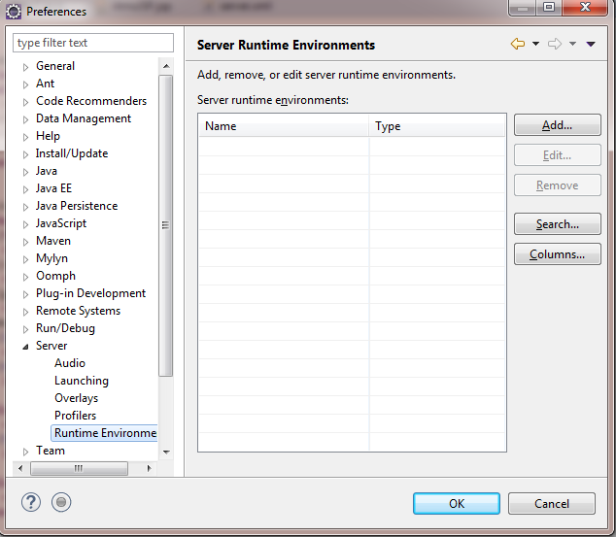

Add the already installed version of Tomcat from the list and Finish the configuration:

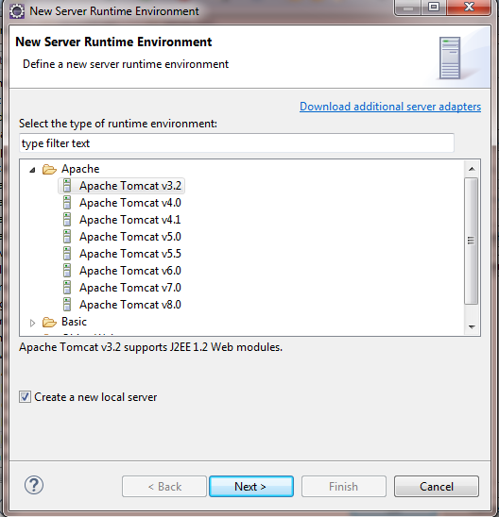

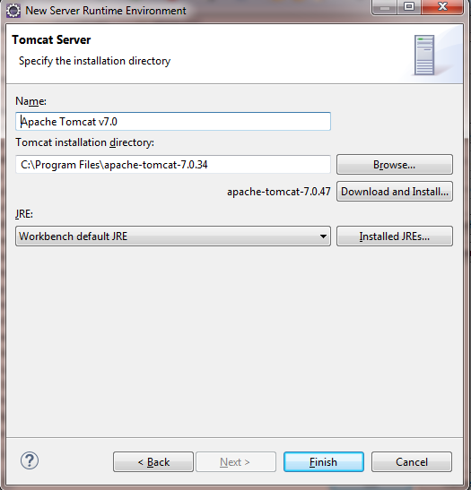

This will add and configure the required version of Tomcat in Eclipse.

Now you can deploy any Web Application using this Tomcat server.

5. DOWNLOAD POSTGRESQL INSTALLER FOR WINDOWS

You need to download the installer from PostgreSQL Official website.
- Go to the PostgreSQL official website, download section for Windows, http://www.postgresql.org/download/windows/
- Choose the latest version to download. It will take few minutes to complete the download.

Installation of PostgreSQL step by step
Double click on the installer file, an installation wizard will appear and guide you through multiple steps where you can choose different options that you would like to have in PostgreSQL.
The following illustrates each step and its options for installation. If you install a different version, you may get additional steps.
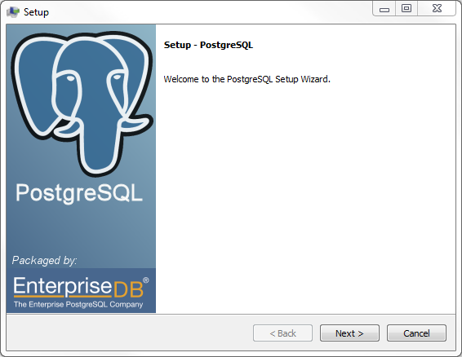

Start Installing PostgreSQL

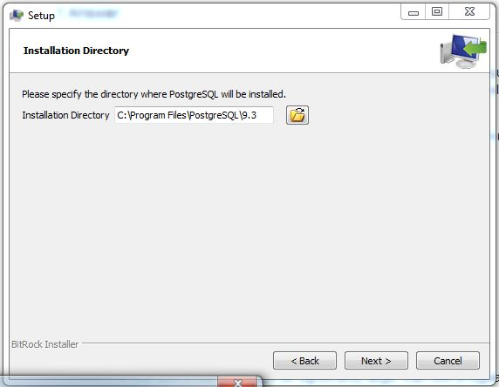

Specify installation directory, choose your own or keep it default.
Specify the directory where you want to store the data
Enter the password for the database superuser and service account.
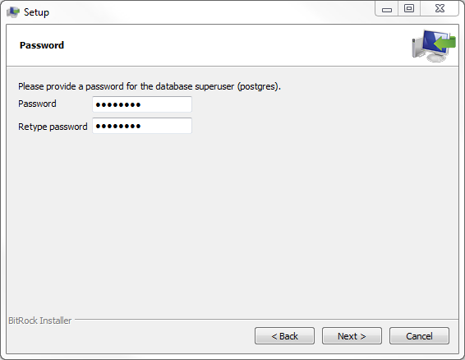
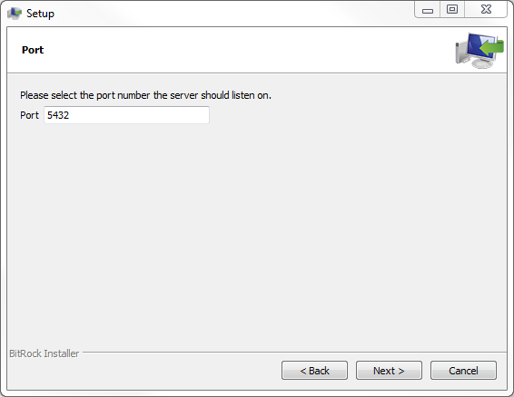

Enter the port for PostgreSQL.
Make sure that no other applications are using this port.
Leave it as default if you are not sure.(In general, Port number 5433 is preferred, and if it is not available then use 5432).

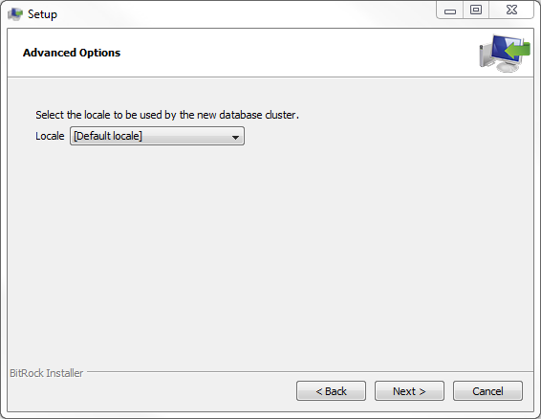

Choose the default locale.
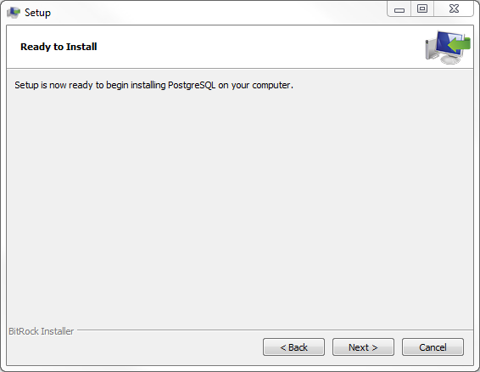

You have finished providing information for the PostgreSQL installer.

Click the Next button to let PostgreSQL Setup to install.
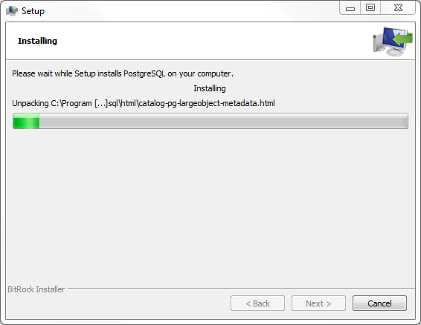

The installation may take few minutes to complete

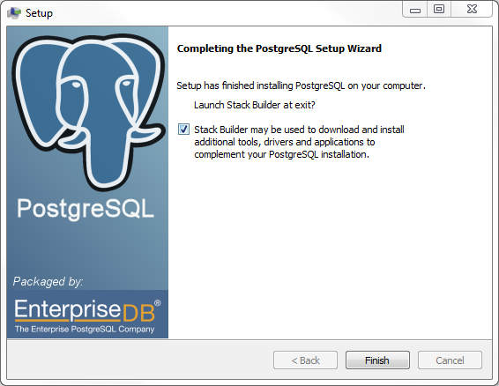

Click Finish button to complete the installation.

Verify the Installation
There are several ways to verify the installation. You can try to connect to the PostgreSQL database server from any client application e.g., psql, pgAdmin, etc.
The quick way to verify the installation is through the pgAdmin application.
Go to the pgAdmin official website, download section for Windows, http://www.pgadmin.org/download/windows.php

First, click on pgAdmin III to launch it. The pgAdmin III GUI will display.
And Then follow the instruction given in the Setup Windows.

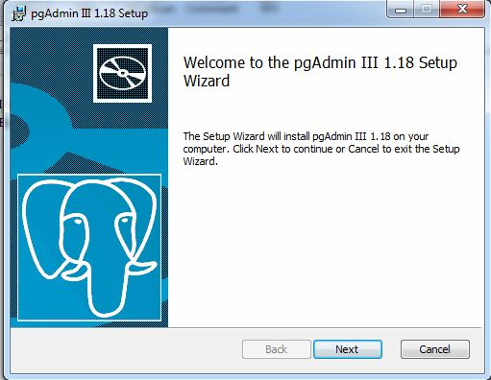

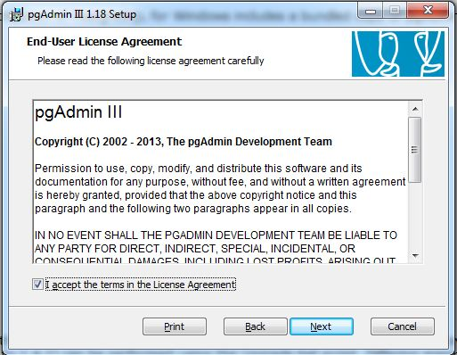

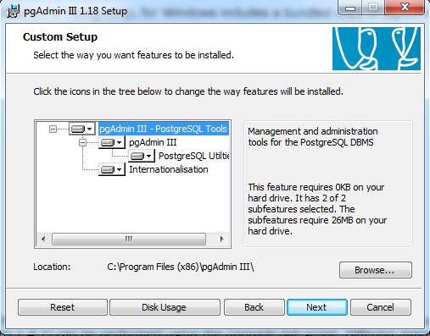

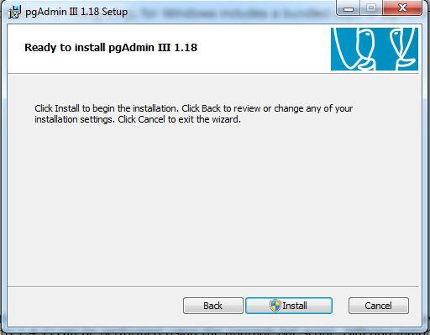

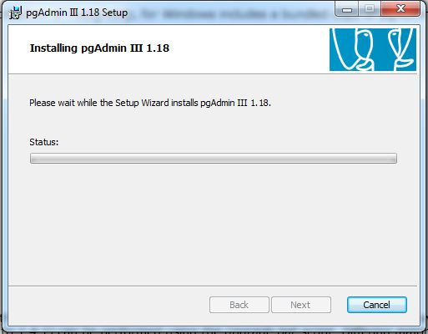

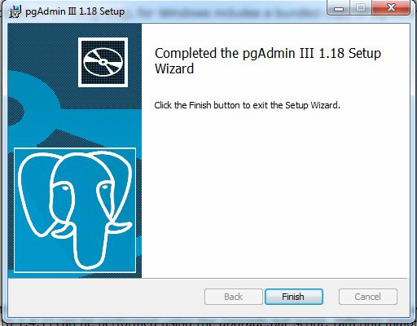
The password-setup assistance for pgAdmin III is given below if the given error condition arises :

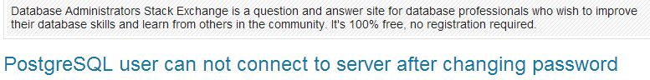

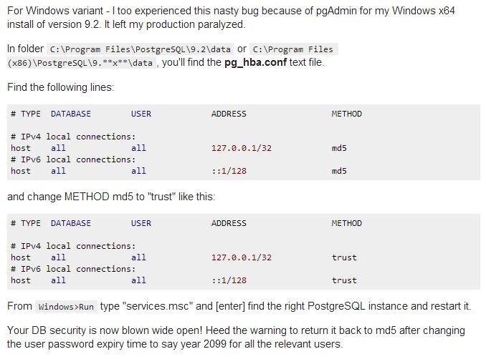

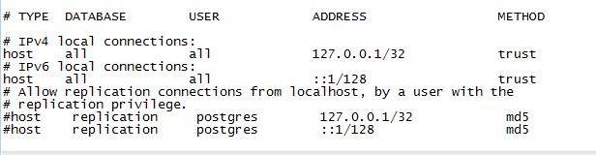

PgAdmin III UI Console will then be ready for database operation, as given below:
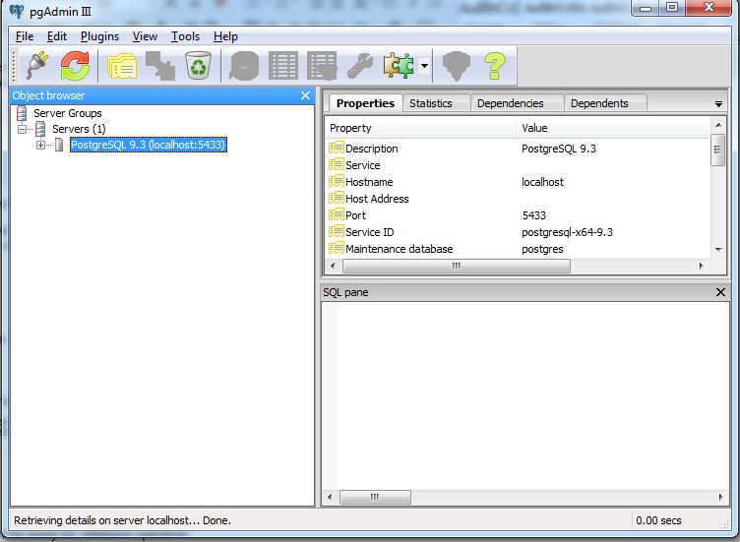

6. SAMPLE DATABASE CONNECTIVITY WITH POSTGRESQL DATABASE

- Create a sample database in PostgreSQL with required Tables and columns.
- Define Login roles in Postgres with credentials as defined by programmer/user. (Here in this case: User_Id:Sample1; Password: iitms123).
- It will be used while defining username and password along with the URL in Connection with Postgres.
- In order to integrate Postgres with Eclipse we need to add .jar filesof Postgres as given below:

Right Click on Project-Java Build Path-Libraries-Add Externa JARs...

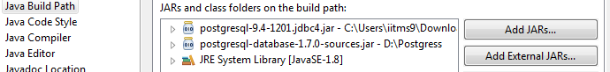

Note:- .jar will be available on the official websites of PostgreSQL.

- Now write a java code to define a connection object by importing required packages.
- The Postgres Driver will be loaded once by the statement given as .
- This will loads the driver of Postgres database .

The Sample Code is attached herewith:

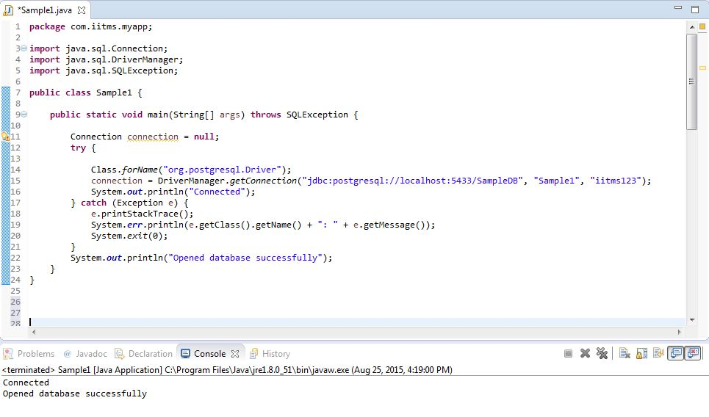

The PostgresDatabase Hierarchical Structure is given below:

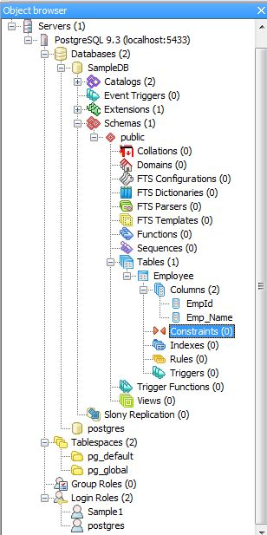

7. UNDERSTANDING JAVA PROJECT STRUCTURE

In Eclipse, the project created will look like:
Folder/Project Structure
- src
- bin
- build
- dist
- lib
The project Name can be different as per programmers/projects requirement. This folder structure may vary in its hierarchy depending upon the type of application (like Enterprise or Standard Application).
The classes can be maintained within the hierarchy mentioned below:

Folder/Project Structure
To create a project in eclipse, you need to click on New project as below:

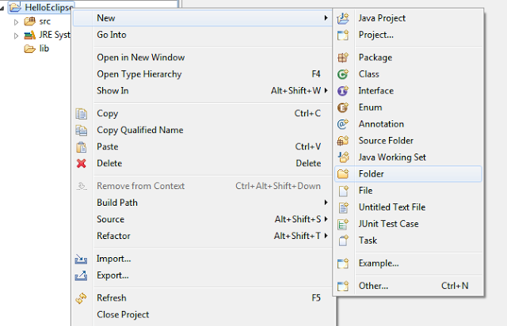
Select Folder in New > Right click menu on Eclipse Project.

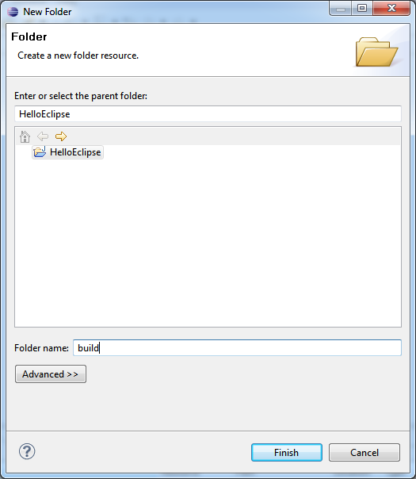
Create a new folder with Folder name

Note-: Creating a folder will be useful when a programmer want to integrate multiple application
in a single Folder.

src
This folder is a place holder of your java packages and classes. Typically all .java files are included in this folder.

bin
This folder holds the compiled .class files. Eclipse will automatically compile all the .java files in your source code to .class files and store them in bin folder under your project structure in workspace. This folder will not be displayed in your eclipse structure but will be present in the path holding all the incrementally compiled java files.

build
This folder will hold the .class files compiled by Source versioning from .java files. Build folder will be actually the folder that will hold all .class files compiled by our own specific set of compilation flags and setting if any.

dist
This folder should hold your deliverable's like jars which you intend to deliver and distribute for the development of an application.

lib
This folder holds the external libraries which you intend to use in your project for developement of application.
Apart from the above folder structure, user can create other folders catering to the needs of a particular project or product. The end project structure should look something similar to what is shown below.
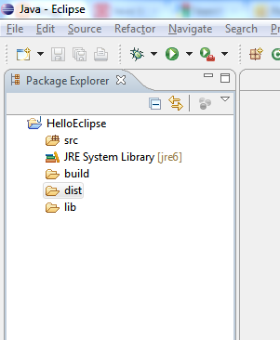
This is how your folder structure should look like.

8. DIRECTORY STRUCTURE OF FILES/CLASSES IN ECLIPSE

Following are the Standard ways of naming classes within a package in Eclipse:

- com.mycomapany.myapp
Main class as MyApp(with main method/Controller/Servlet)

Here in this case, “com.mycompany.myapp” is the name of package consisting of different subpackages and classes. It will create a a class “MyApp” consisting of Main Method and will act as Controller or Controller Servlet.

- com.mycomapany.myapp.model
Domain Model Class ,like Customer, Order,Food, Quality etc.

- com.mycomapany.myapp.ui
User Interface (Presentation/JSPs/JSF/HTML or View Code)

- com.mycomapany.myapp.service
Services within your application includes Business Logic.

- com.mycomapany.myapp.util
Helper and other utility classes used in several places.

9.REFERENCES

Apache Tomcat:
http://tomcat.apache.org/

First Servlet Creation:
http://www.srccodes.com

10. DOCUMENT CONTROL

Change History

Version | Date | Author | Approver | Comment
0.1 | 07/09/2015 | Anand Padwalkar  Preeti Deshmukh |  | First draft version

Open Issues

Opening Version | Date | Author | Action | Owner | Status | Closing version

